Bar Hill Pre-School
Uniform order form
We have the following items available to purchase, if you wish, which are printed with the Pre-School logo. Please complete form and return with payment.
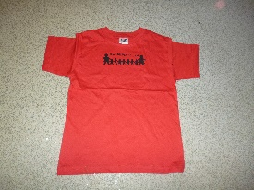
T-shirts
Available in sizes
22’’ (2-3 years)
24’’ (3-4 years)
26’’ (5-6 years) Price £6.25
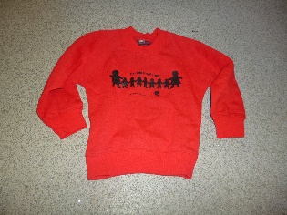
Sweatshirts
Available in sizes
22’’ (2-3 years)
24’’ (3-4 years)
26’’ (5-6 years) Price £10.25

Special offer-
Purchase 1 t-shirt and 1 sweatshirt for £15.00

Please complete order form below-
Item | Size | Quantity | Price
T-shirt
Sweatshirt
T-shirt and sweatshirt

Child’s name ………………………………………………………
Payment type Cash / bacs payment £…………………………
Bacs details- Bar Hill Preschool sort code 08-92-99 account number 65685800 using child’s name as reference.

